**IT Book Borrowing Management System**

Objectives

1. Develop a borrowing management system for IT books for efficient transactions between librarians and students.
2. Design a data model for books, profiles, and transactions.
3. Create the admin page, librarian page, and student page.
4. Integrate Google SignIn API for authenticating users using EVSU account.

Organization of a project

1. **Scope of the Project**

This project aims to create a system designed to lighten the administrative workload of the university library employees, who now have to manually handle book borrowing requests and maintain records of borrowing history. It will include features such as signing with google using a registered EVSU account, viewing books and their categories, borrowing books, viewing and updating transactions, editing profile data and logging out. The project covers only the IT books that are available in EVSU library.

1. **Project deliverables**

B.1 Kick - off meeting

*insert screenshot with the team (meeting)

**B.2 Methodology**

The SDLC Waterfall model is an appropriate project methodology for the development of the IT Book Borrowing Management System, as it allows for a clear and structured approach to project development and ensures that each phase is completed before moving on to the next step.

**B.3 Project Plan [Gantt Chart]**

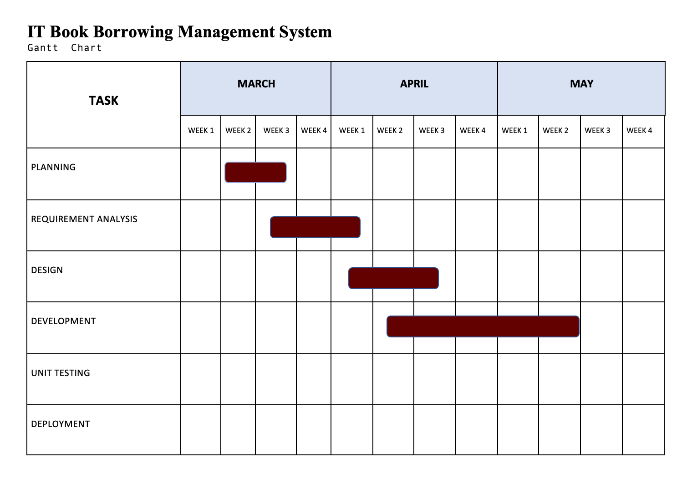

The present study aims to develop a comprehensive plan for system development, leveraging the power of Gantt charts as an essential tool. The study aims to enhance project coordination, optimize resource allocation, and ensure efficient task execution, leading to successful system development within the predetermined timeframes. Through the detailed analysis and application of Gantt charts, this research intends to provide valuable insights into project management methodologies, fostering improved project outcomes and advancing the field of system development.

**B.4 Communications plan**

**B.5 Meeting notes**

* **Planning**

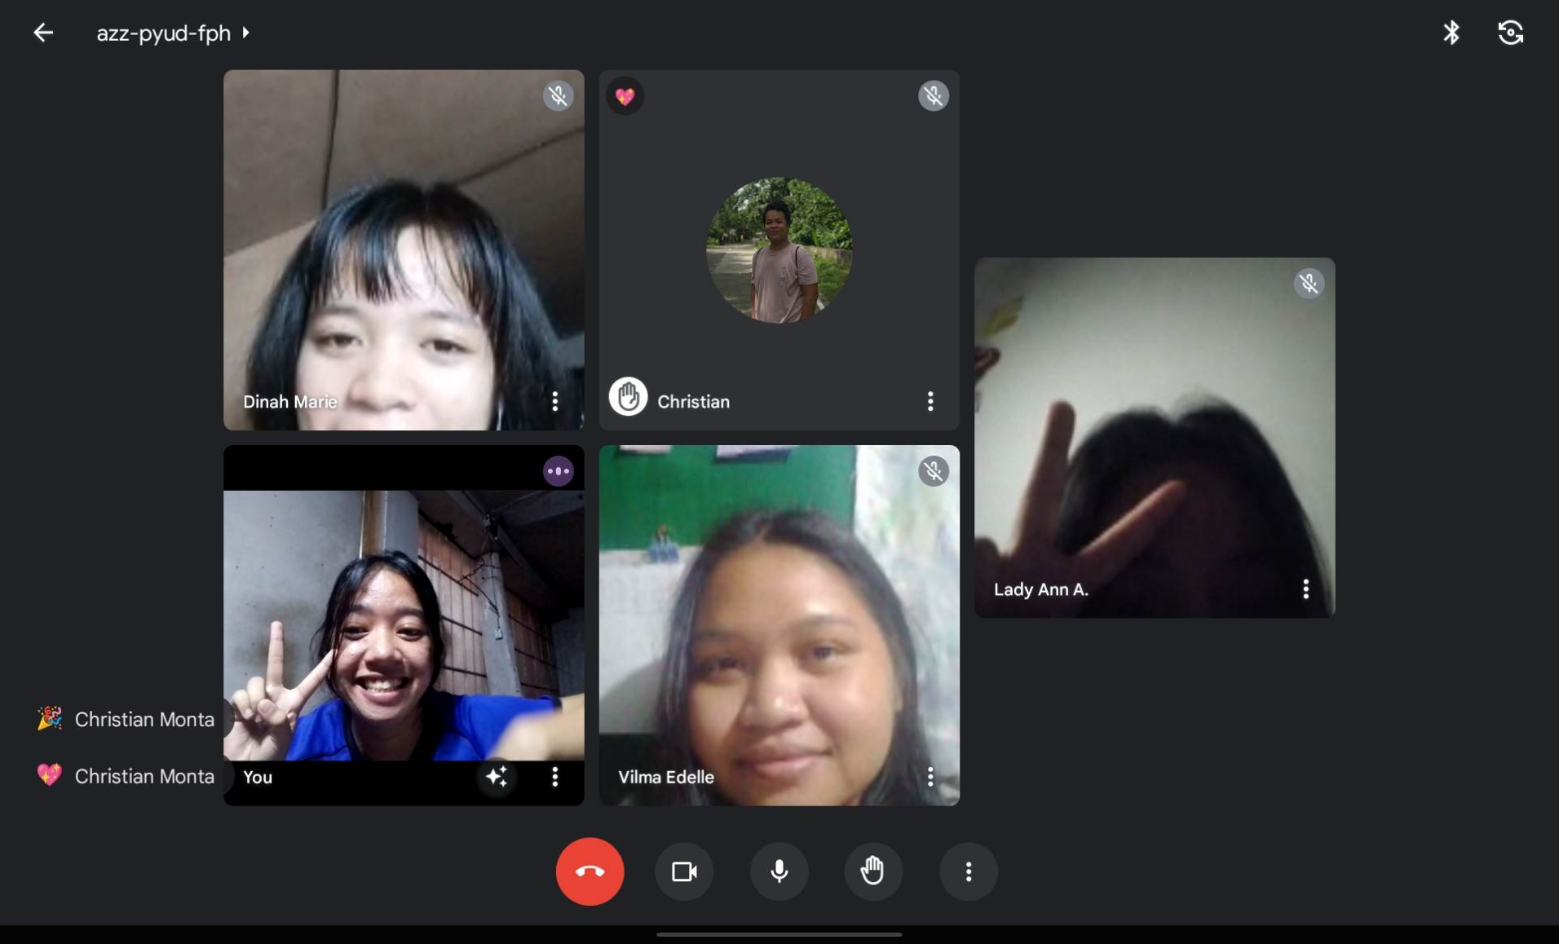

* **Requirements Analysis**

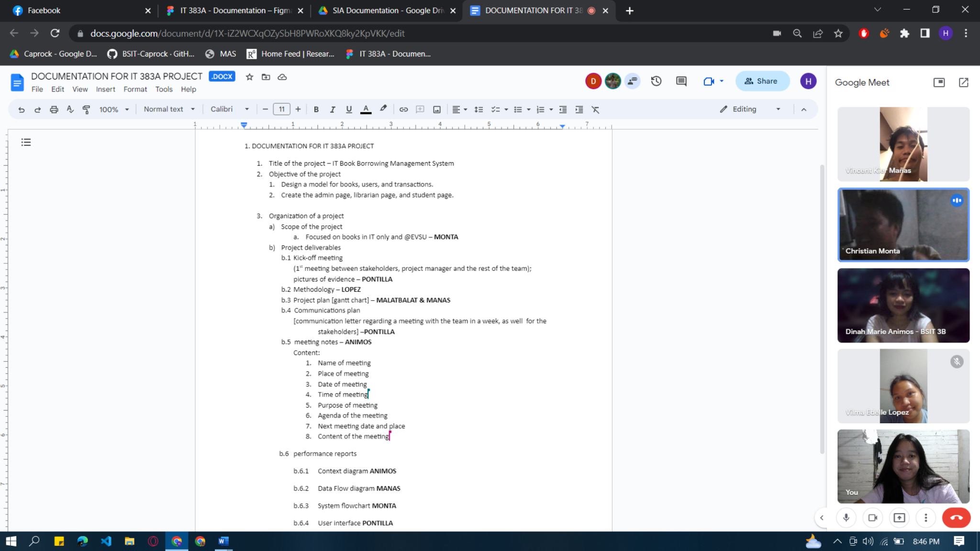

* **Design Phase**

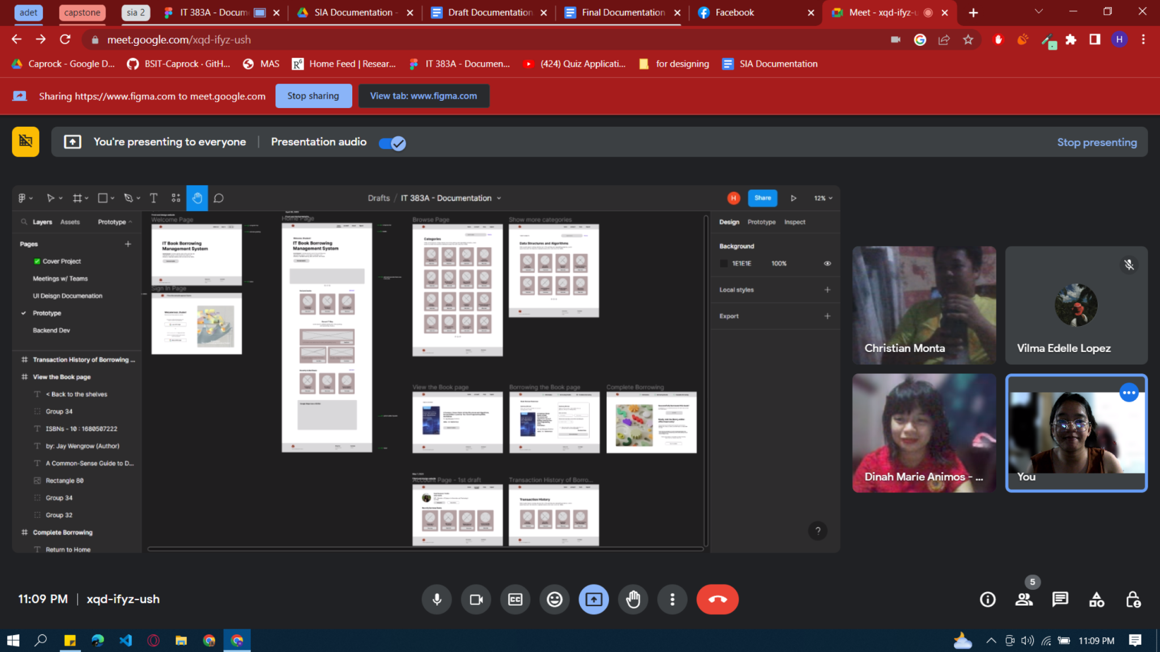

**B.6 Performance Reports**

**B.6.1 Context Diagram**

**B.6.2 Data Flow Diagram**

**Level 1 DFD in Creating An Account**

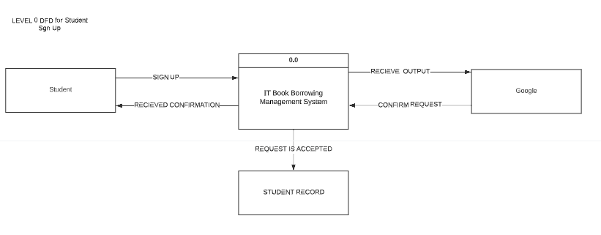

Sign up - when a student create or sign up for an account to be able make use of the system

Google - will be the one to verify and create an account if the student’s email is a verified EVSU email account.The overall processing unit will contain the following output that a system will produce or generate:The student will sign up using Google to be able to create an account in order for the student to make use of the system.

**Level 1 DFD Student Request A Book**

Book request when a student requests for a book.Librarian will be the one to provide the student’s book requestBooks will be the output as the book demanded by the student will be given to them.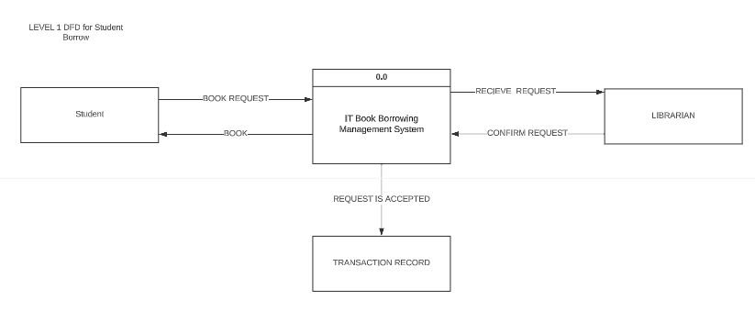

**LEVEL 1 DFD Student Return a Book**

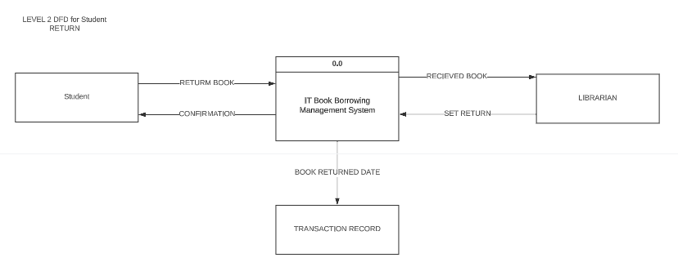

Return book when a student will return the book.Librarian will be the one receiving the borrowed book and updating transaction record.The Confirmation and Transaction will be the output as the book returned by the student will be given to them.

**B.6.3 System Flowchart**

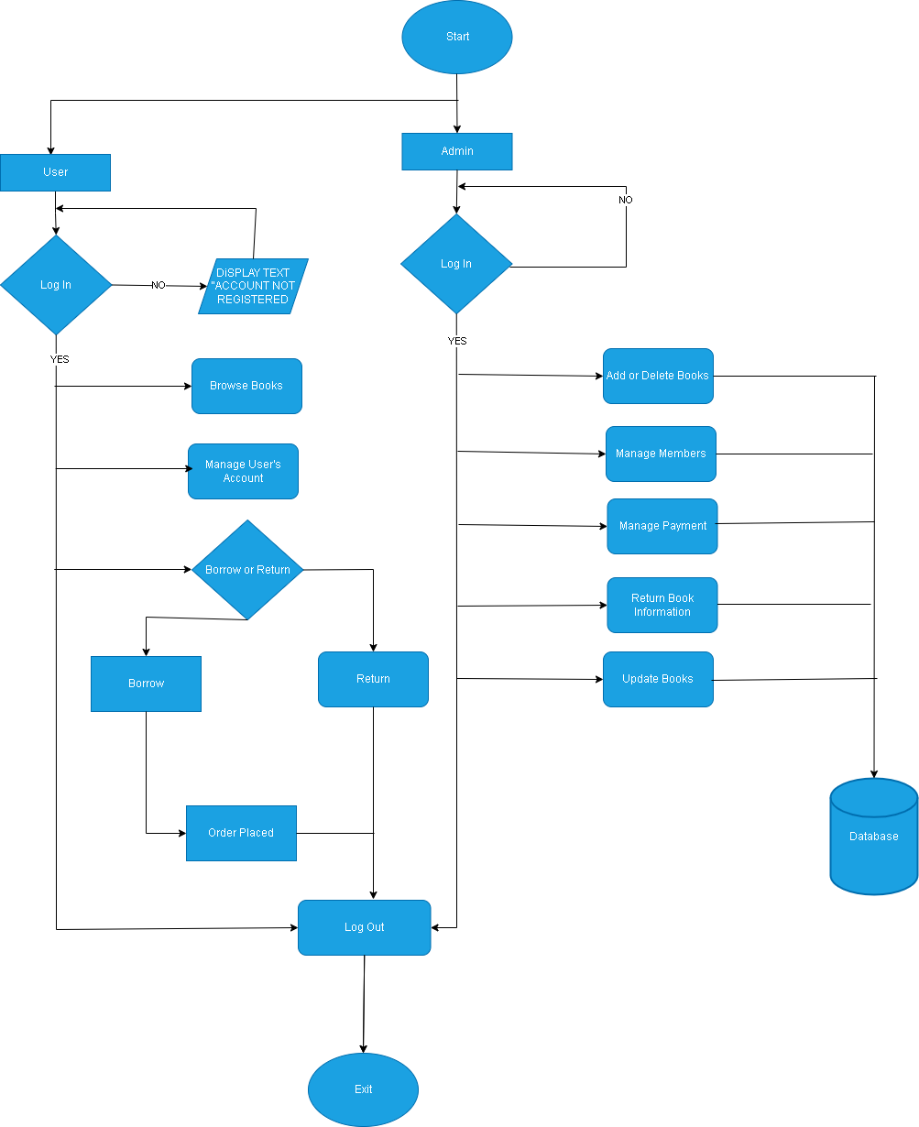

**B.6.4User Interface**

**Students UI**

* Login/Authentication
  + Welcome Page
  + Home Page
* Browse Books
  + Viewing of Categories of Books
  + Picking the Book
  + Borrowing Process
* Dashboard / Account of the User
* Account Management / Transaction History of Borrowing of the Books

**Librarian / Administrator UI**

* Login/Authentication
  + Welcome Page
  + Home Page
* Circulation
  + Viewing the Categories of Books
  + (CRUD) Create, Retrieve, Update and Delete of Books
* Account Management / Viewing of the Books being Borrowed

References:

Full Documentation here

<https://www.figma.com/file/YoqXfI8q8mPZSdb7H5pP7E/IT-383A---Documentation?type=design&node-id=133%3A12&t=E2wJ1cazE4G950JB-1>

Members:

* Pontilla, Hazel Rosemarie T.
* Animos, Dinah Marie
* Malatbalat, Lady Ann
* Monta, Christian
* Manas, Vincent Kier
* Lopez, Vilma Edelle